Application for Fellowship of Otorhinolaryngologists and Head & Neck Surgeons
- Full name :

- Designation :

- Post graduate qualifications :

- Date of Board certification in otolaryngology :

- Date of joining the College of Otorhinolaryngologists and Head and Neck Surgeons of Sri Lanka :
  - Associate member
  - Ordinary member

- Official address : Phone No :

- Residential address : Phone No :

- Address for correspondence :

- Email address :

- Mobile no :

- Participation as a resource person at any college CME / AAS /Workshop

- Participation as a resource person at any other academic activity

- Participation in college activities : college workshops/CME/ as a council member/ sub committee

- Journal publications
Were you a member of the association of Otolaryngologists of Sri Lanka? Yes/no
If yes, date of joining:
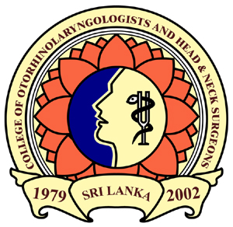
…………………………………….
Signature:

Copies of relevant documents should be submitted with the application.

